**EXPERIMENT NO. 12**

**AIM** : Configuration of networks using static and default routes.

**MATERIALS:**

* 1. Two routers (R1 and R2)
  2. Two computers (PC1 and PC2)
  3. Console cables to connect to routers
  4. Ethernet cables for connecting PCs to routers

**TOPOLOGY:**

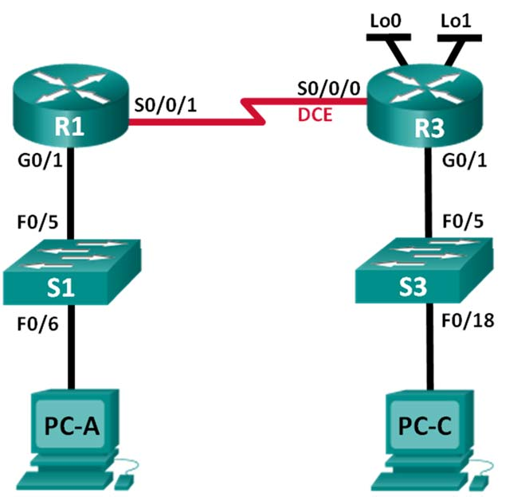

**INSTRUCTIONS:**

1. **Physical Setup:** a. Connect PC1 to R1 using an Ethernet cable. b. Connect PC2 to R2 using an Ethernet cable. c. Connect R1 and R2 using a serial or Ethernet cable.
2. **Initial Router Configuration**: a. Connect a console cable to R1 and R2 and access the routers via a terminal emulator (e.g., PuTTY or HyperTerminal). b. Enter the initial configuration mode using the command **enable**.
3. **Configure IP Addresses:** a. Configure the IP address of R1's Fa0/0 interface: **interface FastEthernet0/0**, **ip address 192.168.1.1 255.255.255.0**, **no shutdown**. b. Configure the IP address of R2's Fa0/1 interface: **interface FastEthernet0/1**, **ip address 192.168.2.1 255.255.255.0**, **no shutdown**.
4. **Static Routing**: a. Configure a static route on R1 to reach the network connected to R2: **ip route 192.168.2.0 255.255.255.0 192.168.1.2**. b. Configure a static route on R2 to reach the network connected to R1: **ip route 192.168.1.0 255.255.255.0 192.168.2.2**. c. Verify the routing tables on both routers using the **show ip route** command.
5. **Default Routing:** a. Configure a default route on R1: **ip route 0.0.0.0 0.0.0.0 192.168.1.2**. b. Configure a default route on R2: **ip route 0.0.0.0 0.0.0.0 192.168.2.2**. c. Verify the routing tables on both routers using the **show ip route** command.
6. **Testing**: a. Try to ping PC2 from PC1. b. Observe the packet flow and routing behavior by checking the routing tables on R1 and R2.
7. **Clean-Up:** a. Remove the static and default routes if necessary using the **no ip route** command. b. Shutdown interfaces on R1 and R2: **shutdown**. c. Disconnect the console cables and power off the routers and PCs.

.

